Device to device 🡪 Flow control   
Process to Process 🡪 Congestion control

In normal road, there will be traffic control mechanism  
In data-transport

CIS UOD

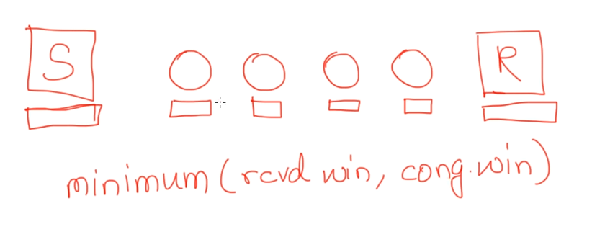

Sender, receiver window 🡪 some-what similar size  
In-between routers 🡪 buffers will be smaller in size.  
Sender is not depend only upon the receivers buffer but also depends upon the intermediate router buffer.

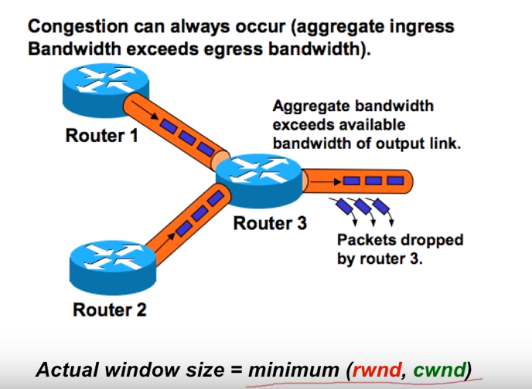  
Router cannot able to proceed further with router-2 and router-3 packets. So it will drop the packets.

# **Congestion**

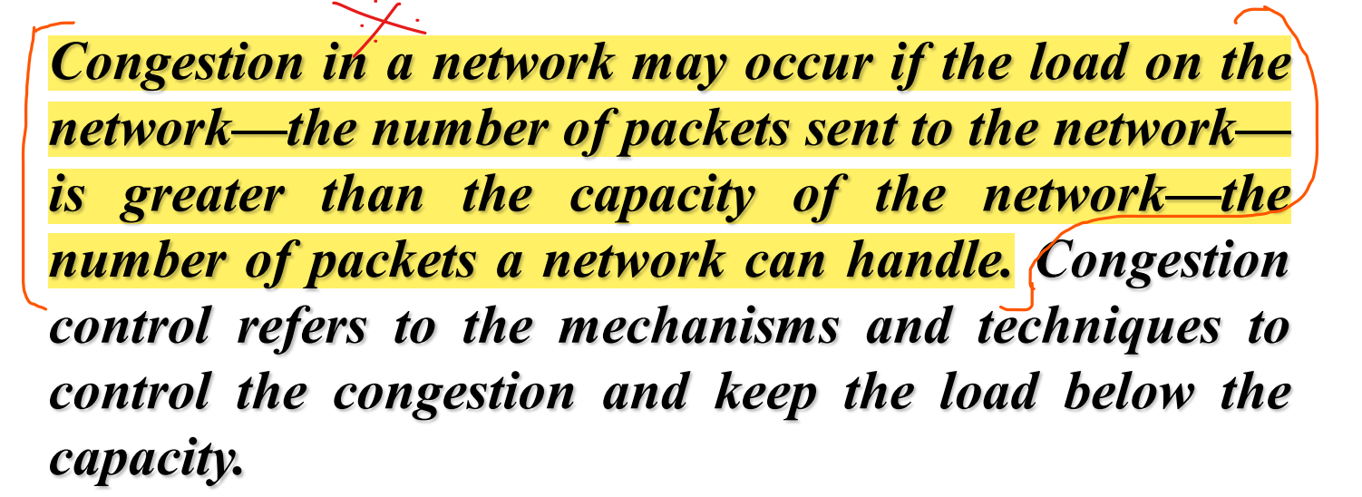

# **Congestion Control**

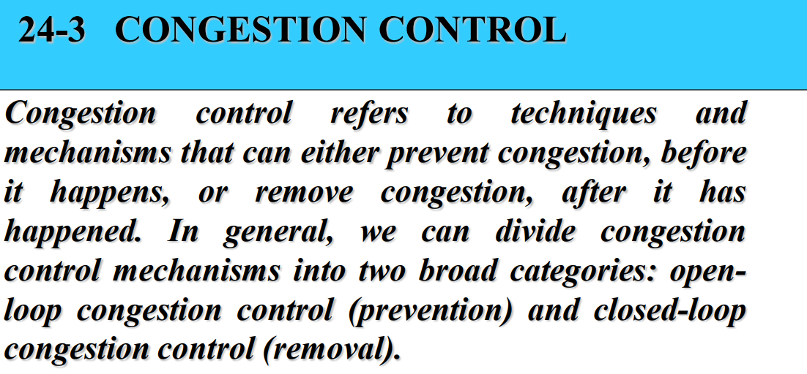

Open Loop Congestion Control 🡪 Prevent the congestion before it happens.  
Close Loop Congestion Control 🡪 Removes the congestion after it happens.

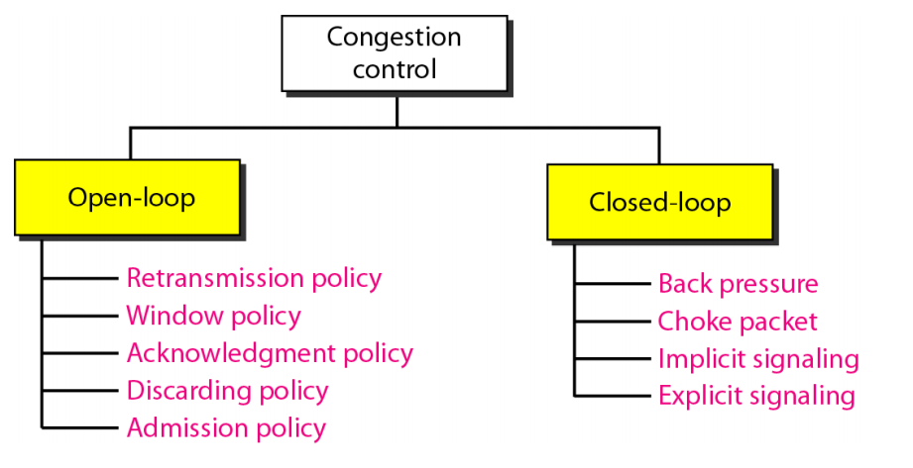

# **Open Loop Congestion Control**

## **Retransmission Policy**

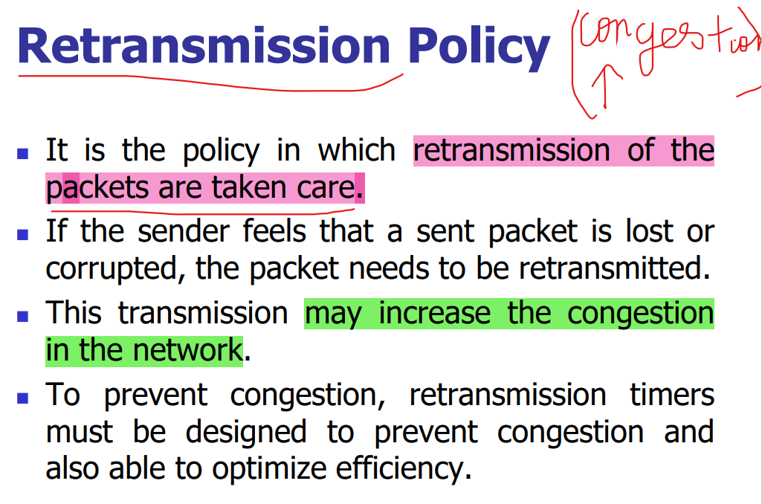

## **Window Policy**

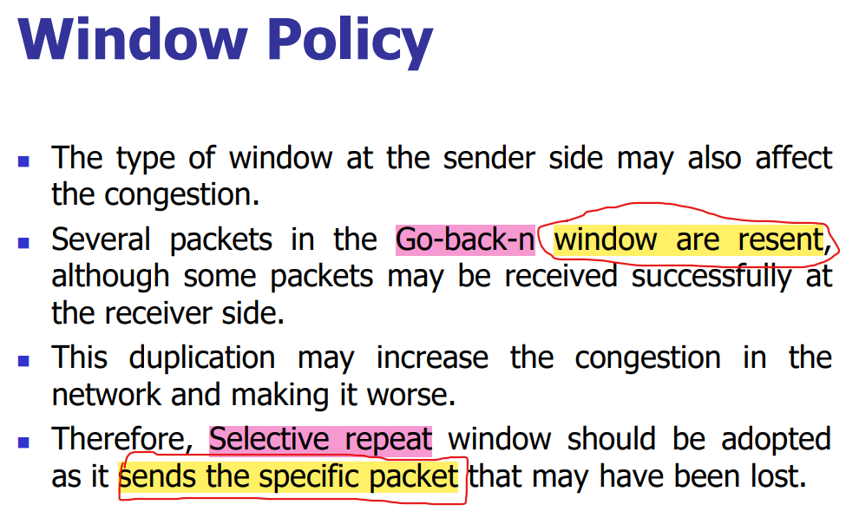

## **Discarding Policy**

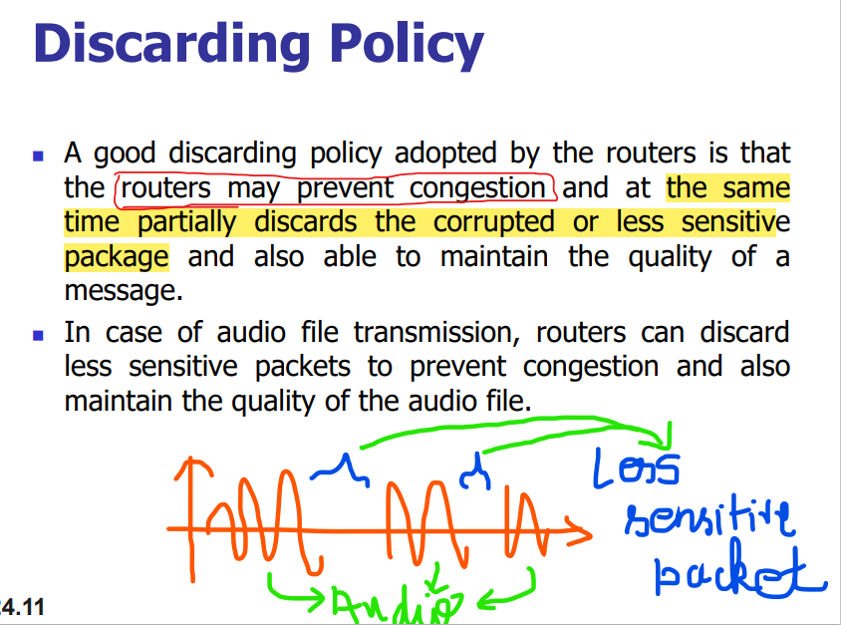  
Corrupted packets are dropped.  
We cannot simply drop the packet. There are also some mechanism to drop this packet.

## **Acknowledgement Policy**

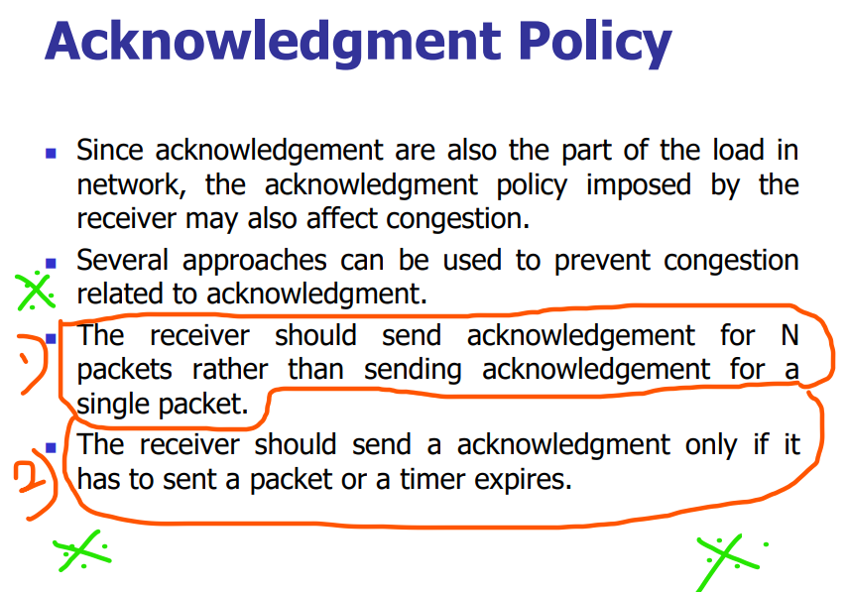

By reducing the number of acknowledgment packets, the congestion can be reduced.  
Receiver should not send the acknowledgment for each and every packet, instead receiver should send the acknowledgment for N packets.

## **Admission Policy**

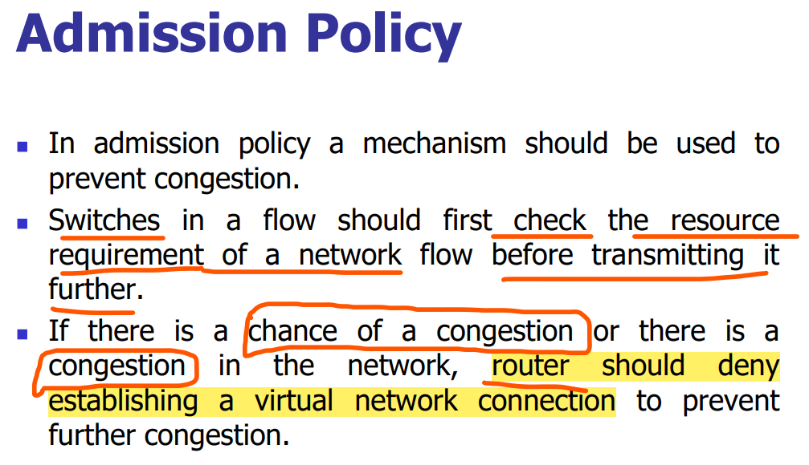

# **Closed-Loop Congestion Control**

Closed loop congestion control technique is used to treat or alleviate congestion after it happens.

## **Back Pressure**

Eg: Dam  
Dams are built across rivers in-order to store the water rather than letting the river water to mix-up with the sea.  
During storing the water, the flow of the water is stopped/slowed down and due to this some back pressure is created which further resists the back-ward movement of the water.

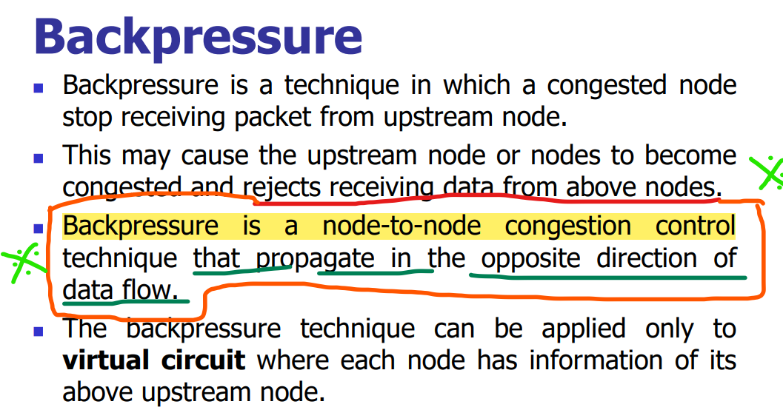  
Forward movement 🡪 Data-flow   
Back-ward movement 🡪 Back-Pressure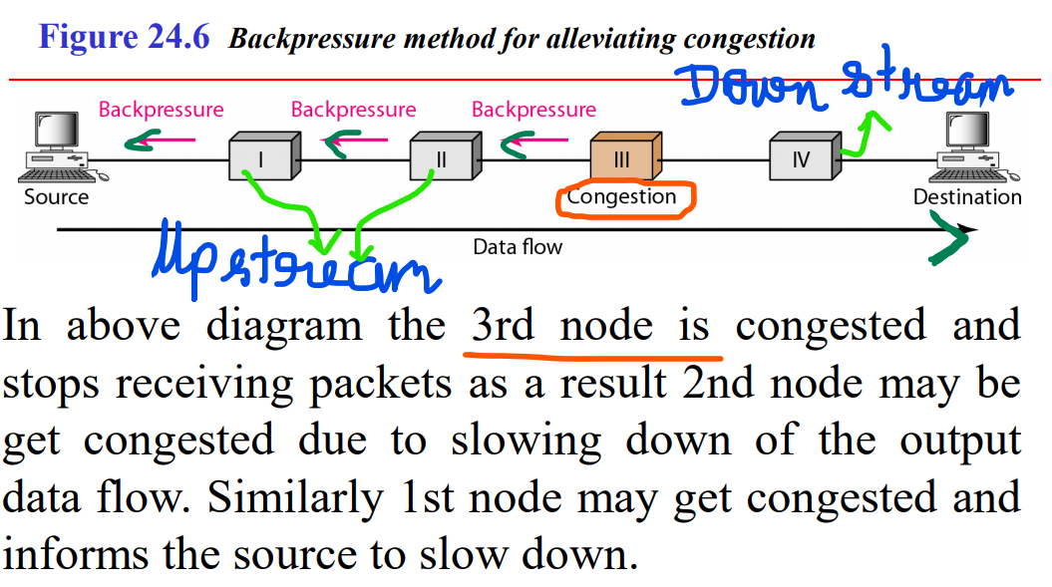

## **Choke Packet**

Congested Router 🡪 A congestion is there, source please stop sending the further packets.  
The intermediate router will not warn about the congestion. These intermediated nodes still passes the packets. Only the congested router will send the choked packet to the source.  
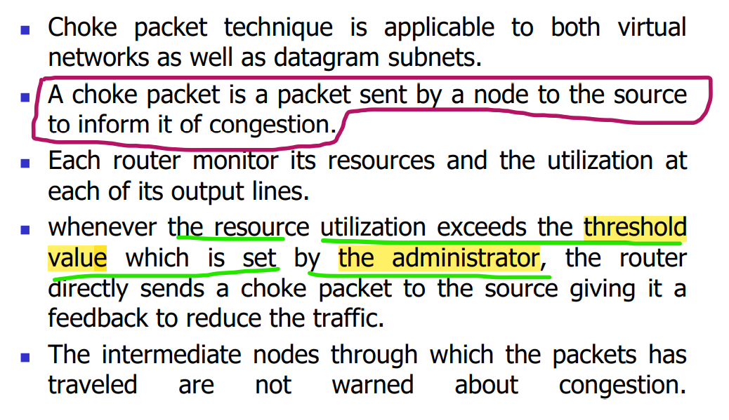

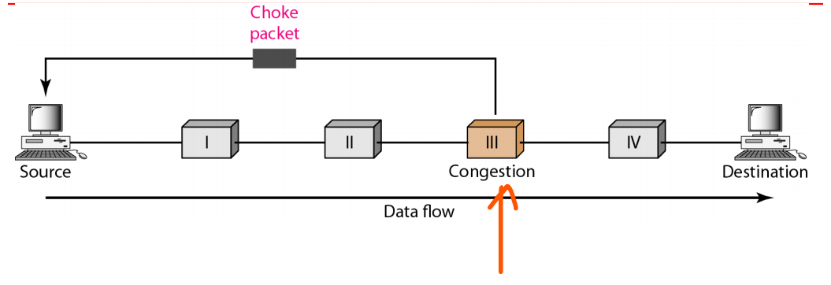

* This congested router’s utilization exceeds the threshold value set by the administrator, so it sends the choked packet to the source.
* Unlike the back-pressure, the congestion node will not disturb the up-stream routers.
* Choke packet are sent directly from congested node to the source.

## **Implicit Signaling**

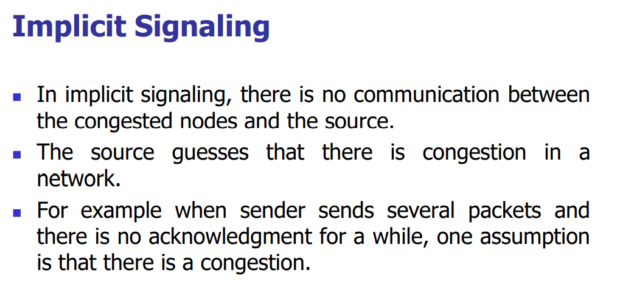

**Sender**  
1st 1 hour sends and receives the acknowledgement without any delay.  
2nd 1 hour sends and receives the acknowledgement with 1 minute delay.  
3rd 1 hour sends and receives the acknowledgement with 5 minute delay.

* Now the sender can clearly understand that there is some congestion in-between so I will reduce the packets. This is implicit.
* No routers in-between told the sender that there is some congestion like choke packer, the ***sender by-itself understands*** that there is some congestion in-between by seeing the delay for the acknowledgement.

## **Explcit Signaling**

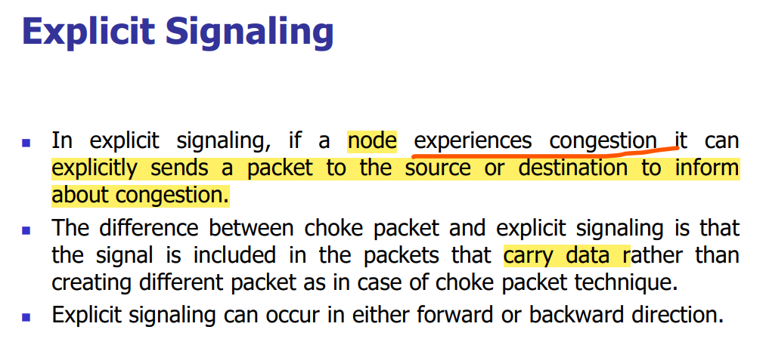

Choke packet 🡪 a special extra packet will be sent to the source to inform about the congestion. Only sent to the source.  
Explicit Signaling 🡪 Data + info about the congestion in a particular router. This is sent both to the source and destination.

### **Forward Explicit Congestion Signaling**

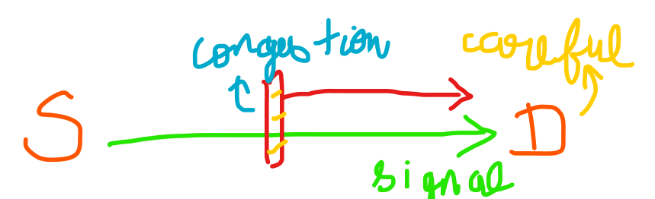  
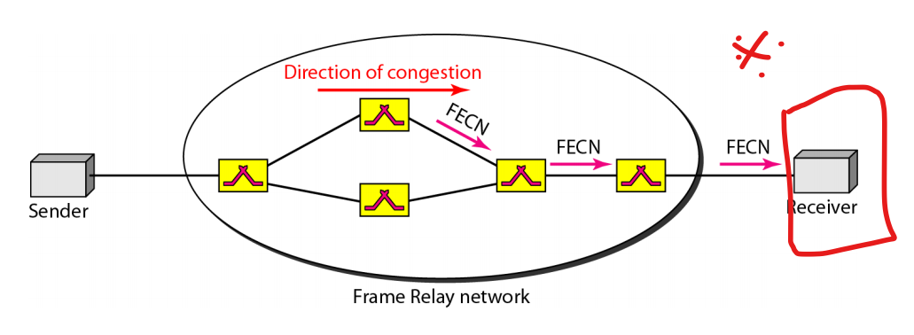  
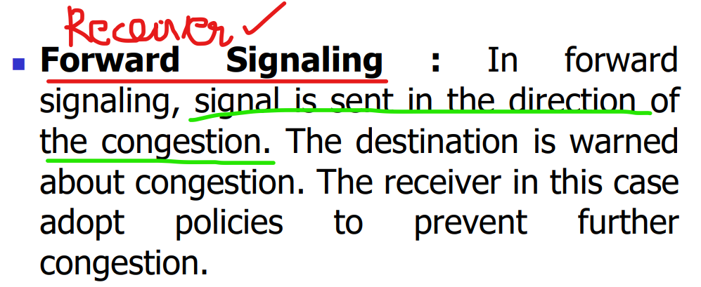

### **Backward Explicit Congestion Signaling**

